**WDSD 2019 - Brief report - Kerala**

**CALICUT:**

The Down Syndrome Trust conducted a full day programme in March 21st at the Calicut Town Hall.

The morning programme was organised in association with the Composite Regional Centre for Persons with Disabilities (CRC-K) and Baby Memorial Hospital, Calicut and was as follows:

09.30 AM: Registration

10.00 AM:

Session 1: **Legal and Social Security for Children with Special Needs**

Mr. Gopiraj P V (Rehabilitation Officer, CRC-Kozhikode)

Session 2: **Need of Physiotherapy in Down Syndrome**

Mr. Binoy Mathew K V (Lecturer & HOD, Dept. of Physiotherapy, CRC-Kozhikode)

Session 3: **Role of parents in the Intellectual & Personality Development of children with DS**

Dr.Beena Johnson (Sr.Consultant, Child Guidance Clinic, Baby Memorial Hospital)

Session 4: **Communication Issues and Significance of Management in Children with DS**

Mrs. Lekshmi Devi R (Speech Therapist, CRC-Kozhikode)

12.30 PM: Colouring competition

This was followed by the Lunch break from 1 PM to 2 PM and lunch was given to all the 250 participants who registered for the morning session, sponsored by the ULCCS Foundation.

The afternoon session was from 2 PM to 4.30 PM and was as noted below:

02.00 PM: Entertainment programmes from various schools

03.30 PM: Meet the Self Advocates

04.00 PM: **Persons with Down Syndrome - Are They Ambitious?**

Prof. (Dr.) A.T.Thressiakutty, Sr.Consultant in Disability Rehabilitation,

Former Senior Expert in Special Education, NIMH, Secunderabad

The Public function started at 4.45 PM along with the Award Ceremony. Every year The Down Syndrome Trust gives two awards; one for a persons with Down syndrome who has excelled as a self advocate and another to a person who has contributed the maximum for the betterment of persons with Intellectual disability especially Down syndrome. The DoST Awards were given to Prof. Dr. Thressiakutty A.T. and Ms. Anita Menon. Sri U.V. Jose (IAS) Jt. Commissioner, Land Revenue Department and CEO, Life Mission was the Chief guest The Agenda of the programme was as follows:

Prayer : Master Abhimanyu

Welcome address : Sri. Nazar Babu T. - President, DoST Support Group

Address by Chair : Dr. Shaji Thomas John - Chairman, The Down Syndrome Trust

Address by Chief Guest : Sri. U.V.Jose (IAS) Jt. Commissioner,

Land Revenue Department & CEO, Life Mission

**Introduction of Award Recipients Prof.(Dr.) A.T.Thressiakutty & Ms. Anita Menon**

**Presentation of Awards**

**DoST Special Recognition:**

**Ms. Usha Menon and Mr.Ramdas Kavil (parents of Ms. Anita Menon)**

Reply by Award Recipients

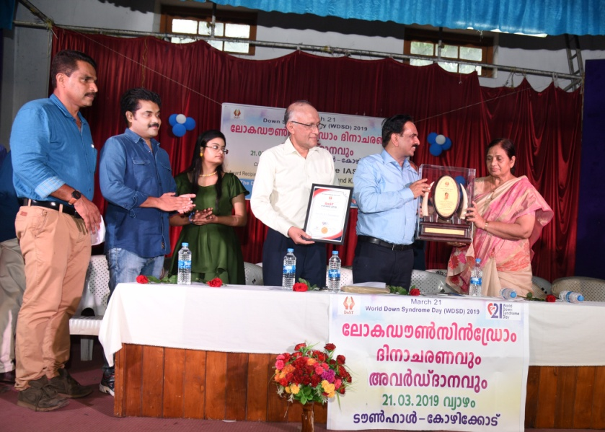

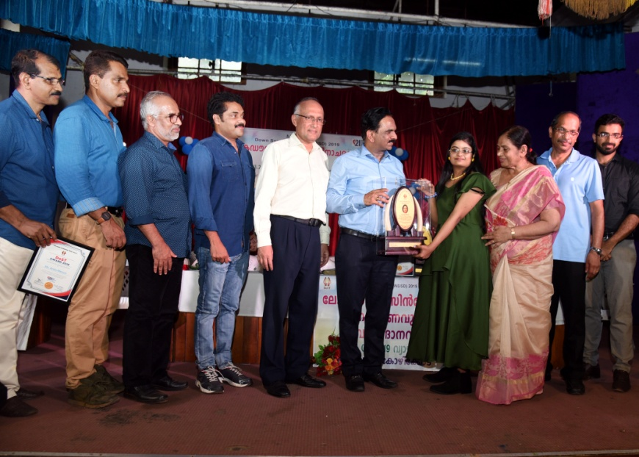

Felicitations : Dr.Roshan Bijlee - Director, CRC-K

: Dr. Jayaraj M.K. - Director, ULCCS Foundation

: Dr. Vijayaram Rajendran - President, IMA Kozhikode

: Dr. Nihas Naha. - Secretary, IAP Kozhikode

Vote of thanks : Sri. Ragesh P.K. - Secretary, DoST Support Group

This was followed by Entertainment programmes by persons with Down syndrome as well as a 'Thiruvathira' dance by the mothers. The magic show by Mr.Raza Ismail Manjeri, a person with Down syndrome and a classical dance by Ms. Dhanya Vijayan another person with Down syndrome were the star attractions. It concluded with a 'free for all' music and dance session for persons with Down syndrome.

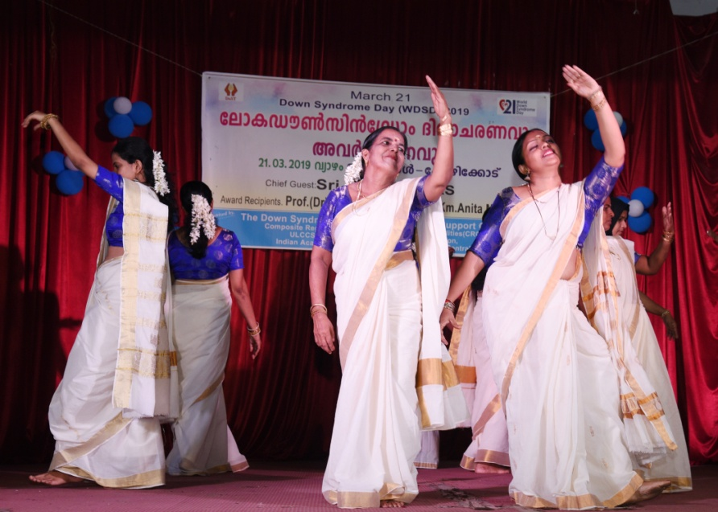

Thiruvathira by mothers

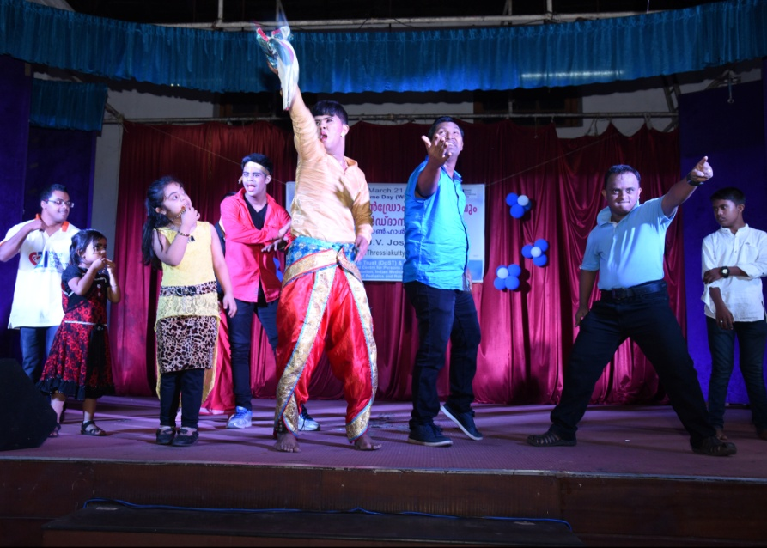

Free style dance for all persons with DS

There was yet another grand programme at **Aster Medcity, Kochi** on 24th March where Dr.Shaji Thomas John was the Chief Guest who gave a talk on "Challenges in raising a child with Down syndrome". There was also a talk by Dr.Maria Grace Teresa on "Promoting communication", a talk by Ms Ameera M on "Promoting Independence", another talk by Ms. Nithya Sara Abraham on " Managing Behaviour" and yet another by Dr.Susan Mary Zachariah on "Follow up to Adulthood"

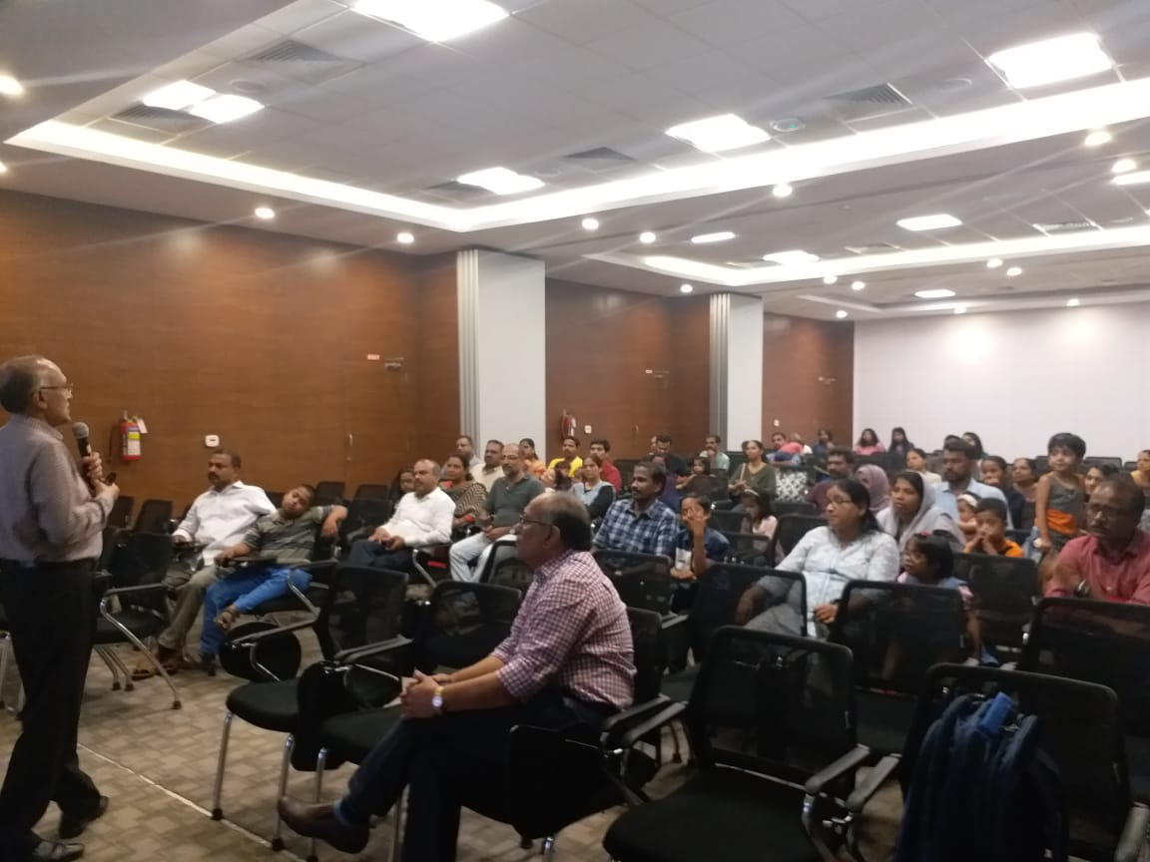

Various other programmes were organised in various medical colleges in Kerala and other branches of Indian Academy of Pediatrics. A **few of them** are as noted below:

There was a get together of parents and children with Down syndrome at the **Calicut Medical College** with cake cutting and music. It was inaugurated by the Principal Prof.Dr. Rajendran.

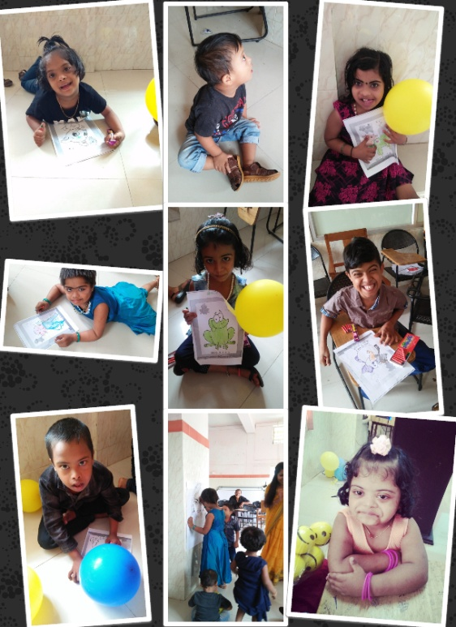

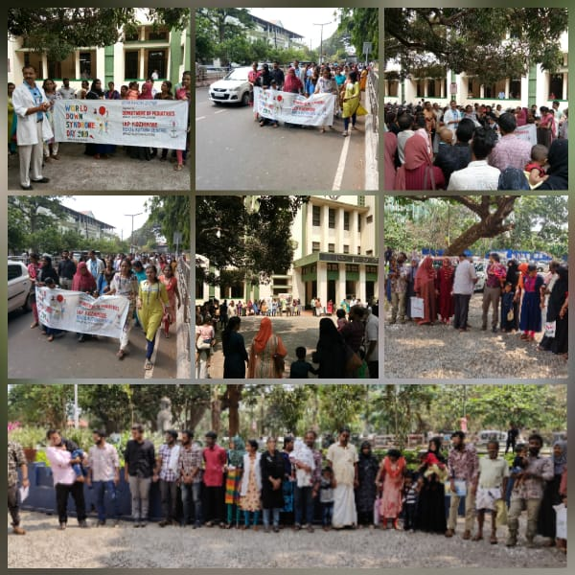

**IAP Pathanamthitta** in association with Pratheeksha, Child Development Centre of Pushpagiri Institute of Medical Sciences, conducted World Downs Syndrome Day.

Rev. Fr. Jose Kallumalickal, CEO Pushpagiri group of Institutions, inaugurated the function in the presence of Prof.Dr. Sukumaran Sir, past national president of IAP.

Prof. Dr. Latha, Department of Paediatrics PIMS, Dr. Manju George Ilanjickal, Dr. Binukuttan, Dr. Jijo Joseph John addressed the gathering.

20 Down syndrome children and their parents attended the function which also showcased various talents of the children . All the participants received gifts as a token of appreciation

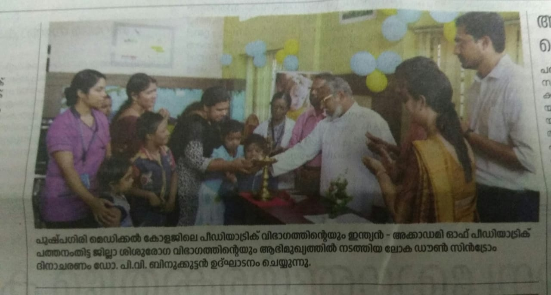

**IAP Kanhangad** organised two programmes on World Down Syndrome Day. Morning at 10.00 am conducted a medical health check up for 30 students of Buds school Nileshwaram. Auditory and Ophthalmic evaluations also done. Dr T V Padmanabhan, Dr Sureshan V, Dr Najoodha and Dr Rahul examined the students.

World Down syndrome day was celebrated at **Al-Azhar Medical College in assosciation with IAP Malanad** on 21.3.19..A talks n classes for public were taken by Dr.Rehna and prefinal year M.B.B.S students..A role play demonstrating a Down syndrome child if given proper care and attention can achieve greater heights was also conducted stressing this year's theme Leave no one behind..

World Down Syndrome Day was observed by **IAP Thrissur** , today at Chaithanya Special School , Kunnamkulam. A picture based quiz was conducted for the differently abled students of the school. Prizes were given for the winners.

There were entertainment programs by the students.

A very informative programme was organised at **Trivandrum** under the leader ship Dr.VH Sankar. It was well appreciated and well attended.

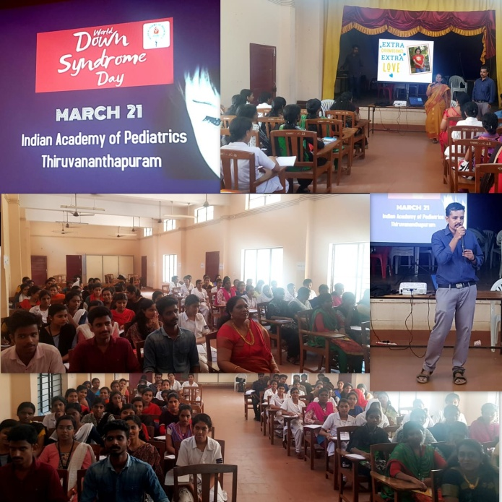

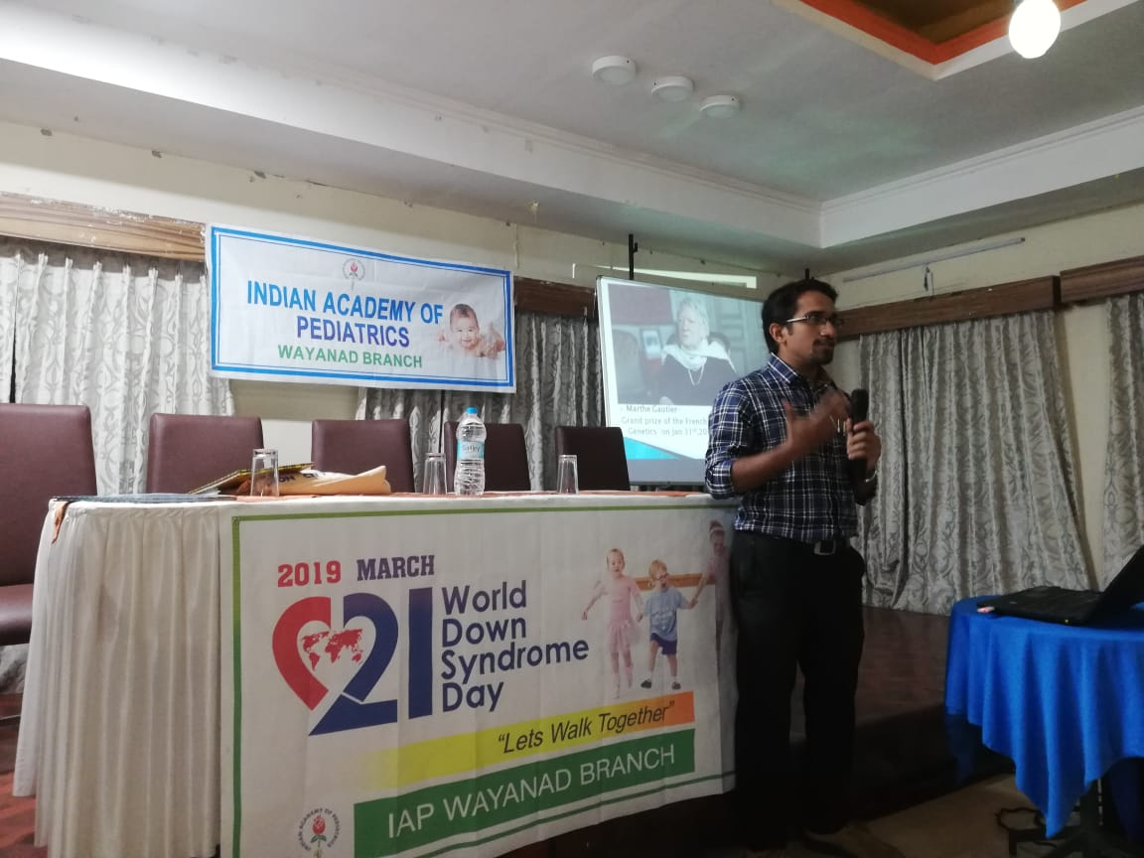

At Wynad